American University of Sharjah  School of Engineering  Computer Engineering Department  P. O. Box 26666 Sharjah, UAE |  | Instructor: Dr. Ghassan Z. Qadah  Lab Instructor: Ms. Praveena Kolli  Office: EB2-126  Phone: 971-6-515-2352  e-mail: pkolli@aus.edu  Semester: Spring 2019

CMP305L Data Structures and Algorithms
Lab8
I’M ABDUL RAHEEM B00075108 DON’T DEDUCT GRADES PLS
Objectives:
- Understand Recursion
- Develop functions using recursion

Exercise 1
- Develop and test a recursive function that calculates the harmonic series:
F(n) = 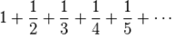
- Develop and test a recursive function that calculates the alternate series:
F(n) = 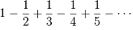
#include<iostream>
#include<cmath>
using namespace std;

double alternating(int n);
double harmonic(int n);

int main() {

int n;
cout << "Enter n" << endl;
cin >> n;

cout << "The sum of the harmonic series to n is " << harmonic(n) << endl;
cout << "The sum of the alternating series to n is " << alternating(n) << endl;

return 0;
}

//Assumes n is positive
double harmonic(int n) {
if (n <= 1) {
return n;
}
else {
return 1.0 / n + harmonic(n - 1);
}

}

//Assumes n is positive
double alternating(int n) {
if (n <= 1) {
return n;
}
else {
return pow(-1.0, n) / n + alternating(n - 1);
}

}
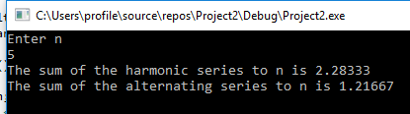
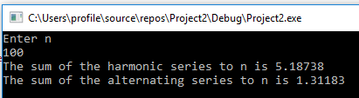
Exercise 2
Develop and test the following recursive function that takes an integer (0 to 9) and prints the output as shown in sample the input/output.

void IntegerPalindrome(int value);

Sample Input/Output:
Enter an integer: 0
0123456789876543210

Enter an integer: 5
567898765

#include<iostream>
#include<cmath>
using namespace std;

void IntegerPalindrome(int value);

int main() {

int n;
cout << "Enter n" << endl;
cin >> n;

IntegerPalindrome(n);

return 0;
}

//Assumes n is positive
void IntegerPalindrome(int value) {
if (value == 9) { cout << value; }
else {
cout << value;
IntegerPalindrome(value + 1);
cout << value;
}

}
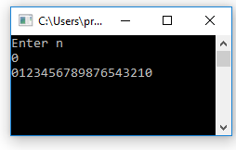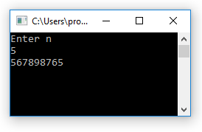
Exercise 3
Develop and test a recursive function that converts the given decimal number into equivalent binary number. No data structure should be used.
#include<iostream>
#include<cmath>
using namespace std;

void binary(int value);

int main() {

int n;
cout << "Enter n" << endl;
cin >> n;

binary(n);

return 0;
}

//Assumes n is positive
void binary(int value) {
if (value == 0) { return; }
else{
binary(value / 2);
cout << value % 2; }

}

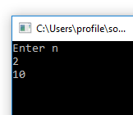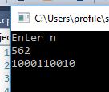
Exercise 4
Write a recursive function string reverse(string s) that, given a string s, returns the string constituted by the characters of s in inverse order. For example the call reverse("pippo") should return the string "oppip”

#include<iostream>
#include<string>
using namespace std;

string reverse(string s);

int main() {

string s;
cout << "Enter s" << endl;
getline(cin, s);

cout << reverse(s);

return 0;
}

//Assumes n is positive
string reverse(string s) {
if (s.length() == 1) { return s; }
else {
return reverse(s.substr(1))+s.substr(0,1);
}

}

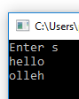

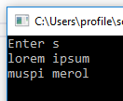
Note: Write a suitable main program to test the functions.

